TO WHOSOEVER IT MAY CONCERN

Anirudh Maity , Ancel Tom Saji, Kalyani Ghadge, Shruti Nagoji Patil, Dr. Atul Kathole are all authors together contribute to a teaching-learning material entitled "AI-Based Crop Disease Detection" which is classified as copyright literary work under copyright act, 1957.

We do not have any conflict of interest for it.
Authors | Signature
Anirudh Maity | 
Ancel Tom Saji | 
Kalyani Ghadge | 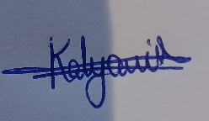
Shruti Nagoji Patil | 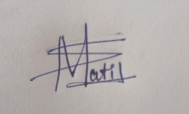
Dr. Atul Kathole | 

